CUSTOMER RETENTION FOR AN ONLINE STORE

INTRODUCTION:

Customer retention is the practice of keeping existing customers engaged and loyal to a business through strategies that encourage repeat purchases and prevent them from switching to competitors. Effective customer retention strategies are crucial for maintaining a stable revenue stream and fostering long-term customer relationships. This project aims to analyze and improve customer retention strategies for an online store.

DATA COLLECTION:

PROCESS:

The data collection process involves gathering and organizing customer data from various sources to understand customer behaviors and preferences comprehensively. This process includes the following steps:

* Identifying relevant data sources.
* Extracting and consolidating data.
* Ensuring data quality and consistency

SOURCES:

The primary sources of customer data for this project include:

* CRM System: Contains detailed customer information and purchase history.
* Web Analytics Tools: Tracks user behavior and engagement metrics on the website.
* Customer Support System: Logs support tickets, resolution times, and customer feedback.
* Email Marketing Platform: Records data on email opens, click-through rates, and promotion usage.

DATA SOURCES:

CRM System: Collects detailed customer information, including:

* Customer ID
* Age
* Gender
* Location
* Income level
* Account creation date
* Purchase history (transaction ID, purchase date, items purchased, purchase amount)

Web Analytics Tools: Monitors user behavior and engagement metrics such as:

* Frequency of visits
* Time spent on site
* Pages viewed
* Interactions on the site
* Customer Support System: Logs data related to:
* Support tickets
* Resolution time
* Customer feedback

Marketing Interactions: Tracks data on email marketing activities:

* Email opens
* Click-through rate
* Promotion usage

TYPES OF DATA COLLECTED:

* Customer Information: Customer ID, age, gender, location, income level, account creation date.
* Purchase History: Transaction ID, purchase date, items purchased, purchase amount.
* Engagement Metrics: Frequency of visits, time spent on site, pages viewed, interactions.
* Customer Support: Support tickets, resolution time, customer feedback.
* Marketing Interactions: Email opens, click-through rate, promotion usage.

IMPORTANCE:

Collecting and analyzing customer data is essential for predicting customer churn and developing targeted retention strategies. Understanding customer behavior helps in identifying at-risk customers and tailoring retention efforts to improve customer loyalty and lifetime value.

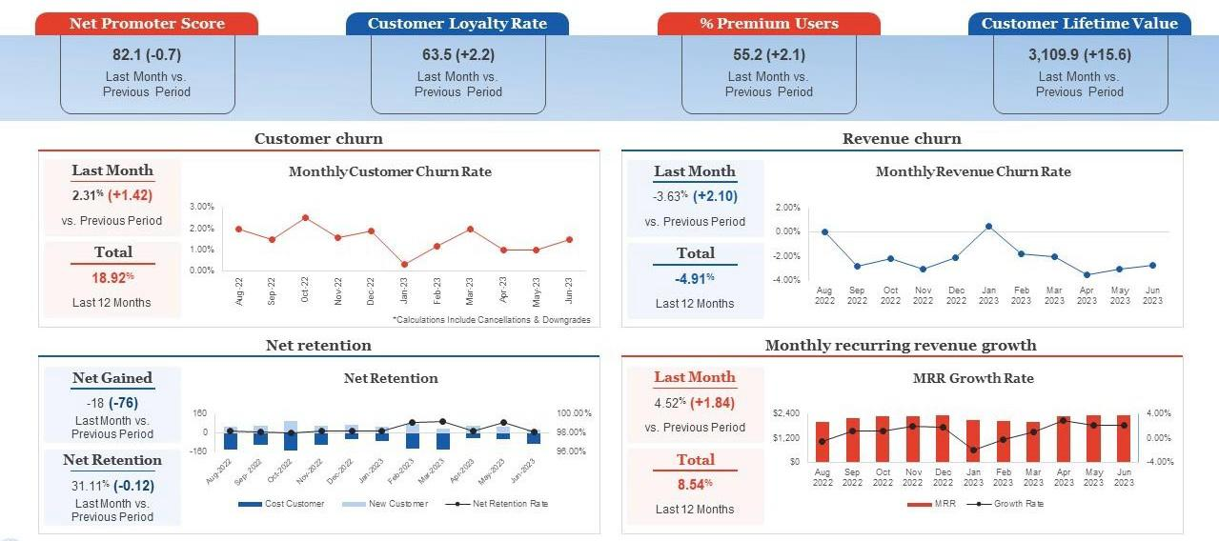

DETAILED DATA ANALYSIS

KEY METRICS:

The analysis focuses on several key metrics to understand customer behavior and retention rates:

Net Promoter Score (NPS): Measures customer loyalty and the likelihood of recommending the store.

* Current NPS: 82.1 (decreased by 0.7)

Customer Loyalty Rate: Percentage of customers who remain loyal to the store.

* Current Loyalty Rate: 63.5% (increased by 2.2%)

Percentage of Premium Users: Proportion of users subscribed to premium services.

* Current Premium Users: 55.2% (increased by 2.1%)

Customer Lifetime Value (CLV): Total revenue expected from a customer over their lifetime.

* Current CLV: $3109.9 (increased by $15.6)

Customer Churn Rate: Rate at which customers stop doing business with the store.

* Last Month: 2.31% (increased by 1.42%)
* Last 12 Months: 18.92%

Revenue Churn Rate: Revenue lost due to customer churn.

* Last Month: -3.63% (increased by 2.10%)
* Last 12 Months: -4.91%

Net Retention: Net change in customers.

* Net Gained: -18 (decreased by 76)
* Net Retention Rate: 31.11% (decreased by 0.12%)

Monthly Recurring Revenue (MRR) Growth: Growth in recurring revenue.

* Last Month: 4.52% (increased by 1.84%)
* Last 12 Months :8.54%

DATA PREPROCESSING STEPS

Data Cleaning:

* Remove duplicates.
* Handle missing values.
* Ensure data consistency.

Feature Engineering:

* Calculate average purchase value.
* Determine recency (time since last purchase).
* Calculate frequency (number of purchases).
* Assess monetary value (total amount spent).

Data Splitting:

* Split data into training and testing sets to prepare for model training.

CUSTOMER SEGMENTATON

Criteria:

* Customer Loyalty Rate.
* Percentage of Premium Users.
* Customer Lifetime Value.

Method:

* Use K-means clustering to group customers into categories such as high-value frequent shoppers and at-risk customers.

Visualization:

* Create charts or graphs to illustrate different customer segments, showing the distribution and characteristics of each segment.

CUSTOMER CHURN :

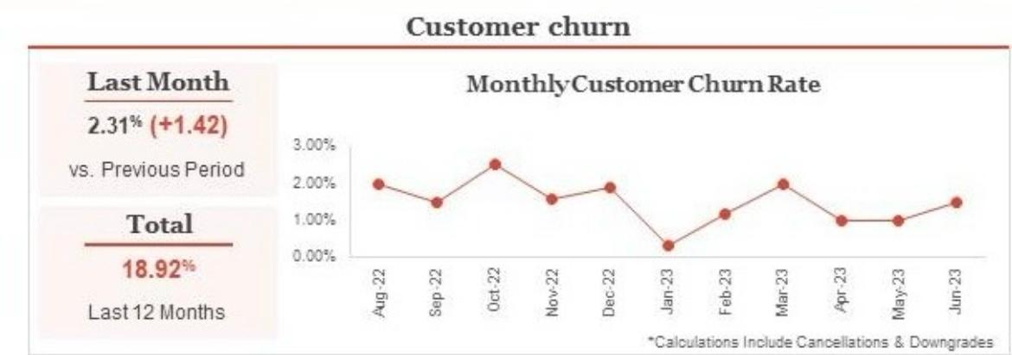

REVENUE CHURN :

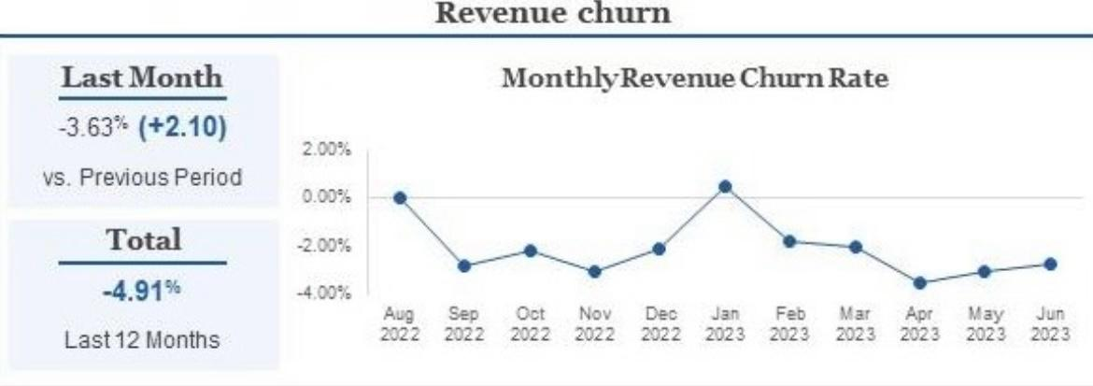

NET RETENTION :

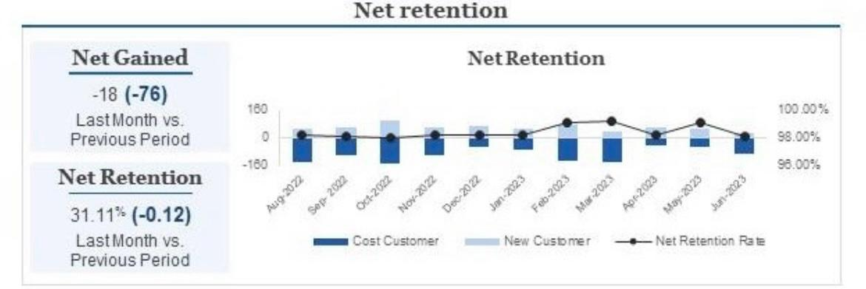

MONTHLY RECURRING REVENUE GROWTH :

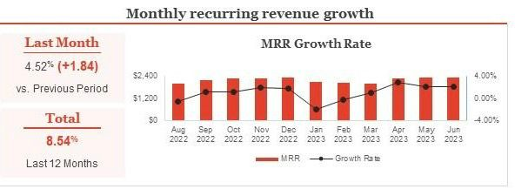

CHURN PREDICTION MODEL

Feature Selection:

* Select features including NPS, Loyalty Rate, Premium Users, CLV, and Engagement Metrics for the model.

Model Training:

* Algorithms: Use logistic regression and random forests.
* Data: Train the model using historical customer data.

Model Evaluation:

* Metrics: Evaluate the model using accuracy, precision, recall, and F1-score.

Model Interpretation:

* Identify key factors contributing to customer churn.
* Develop targeted retention strategies based on these insights.

GRADIENT BOOSTING MODEL

GRADIENT BOOSTING:

Gradient Boosting is a powerful machine learning technique used for both regression and classification tasks. It builds models sequentially, with each new model attempting to correct the errors made by the previous models. This method combines multiple weak learners (typically decision trees) to create a strong predictive model.

How Does Gradient Boosting Work?

Initialization: Start with an initial model, often a simple model like the mean of the target values for regression tasks.

Iterative Training:

For each iteration:

* Compute the residuals (errors) between the actual target values and the predictions from the current ensemble of models.
* Train a new model (weak learner) to predict these residuals.
* Add the predictions of this new model to the ensemble's previous predictions.

Update Rule:

* The model is updated in each iteration by adding the new model's predictions, scaled by a learning rate.
* The learning rate helps to control overfitting by scaling down the contribution of each new model.

How to Implement Gradient Boosting

Steps to Implement Gradient Boosting for Customer Retention

1. Define the Problem:

* The target variable is whether a customer churned or not (binary classification: 0 for no churn, 1 for churn).
* Features can include customer demographics, transaction history, service usage, customer service interactions, etc.

1. Data Collection and Preparation:

* Gather data from various sources such as CRM systems, transaction logs, customer service records.
* Clean and preprocess the data (handle missing values, encode categorical variables, normalize numerical features).

1. Feature Engineering:

* Create new features that can help in predicting churn, such as average purchase value, frequency of transactions, customer service call frequency, etc.

1. Split the Data:

* Split the data into training and test sets to evaluate model performance.

1. Model Building:

* Use Gradient Boosting for the classification task. Libraries like scikit-learn, XGBoost, LightGBM, and CatBoost are popular choices.

1. Evaluation:

* Evaluate the model using metrics such as accuracy, precision, recall, F1-score, and AUC-ROC.

1. Hyperparameter Tuning:

* Optimize hyperparameters using techniques like Grid Search or Random Search to improve model performance.

1. Prediction and Action:

* Use the trained model to predict churn probabilities.
* Implement retention strategies for high-risk customers, such as personalized offers, improved customer service, or loyalty programs.

Interpreting Results and Taking Action

Interpreting Results:

* High ROC AUC score indicates a good model performance.
* Precision and recall help understand the balance between false positives and false negatives.

TAKING ACTION:

* For customers with high churn probabilities, implement retention strategies such as:
* Personalized marketing campaigns.
* Discounts or special offers.
* Enhanced customer support.
* Loyalty programs.

CUSTOMER RETENTION STRATEGIES

1.Exceptional Customer Service

* 24/7 Support: Provide round-the-clock customer service to address any issues or concerns promptly.
* Multichannel Support: Offer support via email, phone, chat, and social media to ensure accessibility.

2. Personalized Experience

* Personalized Recommendations: Use customer data to suggest products based on their past purchases and browsing history.
* Birthday and Anniversary Offers: Send personalized offers and discounts on special occasions.

3. Loyalty Programs

* Reward Points: Implement a points-based system where customers earn points for each purchase, which can be redeemed for discounts or free products.
* Exclusive Membership: Offer a VIP membership with special perks such as early access to sales, exclusive discounts, and free shipping.

4. Email Marketing

* Regular Updates: Send regular newsletters with updates on new products, upcoming sales, and exclusive offers.
* Cart Abandonment Emails: Remind customers about the items left in their cart with an incentive to complete the purchase.

5. Social Media Engagement

* Interactive Content: Share engaging content such as polls, contests, and user-generated content to keep your audience engaged.
* Responsive Interaction: Quickly respond to comments and messages to build a community around your brand.

6. Quality Products and Services

* High-Quality Products: Ensure that your products meet high-quality standards to build trust and satisfaction.
* Reliable Shipping: Provide reliable and fast shipping options with accurate tracking information.

7. Feedback and Reviews

* Solicit Feedback: Regularly ask for customer feedback to improve your products and services.
* Display Reviews: Showcase customer reviews and testimonials on your website to build trust and credibility.

8. Retargeting Campaigns

* Retargeting Ads: Use retargeting ads to reach customers who have visited your site but didn’t make a purchase.
* Email Retargeting: Send personalized emails to customers who haven’t shopped in a while, offering special discounts to entice them back.

9. Seamless User Experience

* Easy Navigation: Ensure your website is user-friendly with easy navigation and a clear layout.
* Mobile Optimization: Optimize your website for mobile devices to provide a smooth shopping experience on all platforms.

10. Incentives and Promotions

* Flash Sales: Run occasional flash sales with limited-time offers to create urgency.
* Referral Programs: Encourage customers to refer friends by offering them rewards for successful referrals.

11. Consistent Branding

* Brand Identity: Maintain a consistent brand identity across all platforms to create a strong, recognizable brand.
* Engaging Storytelling: Share your brand’s story and values to create a deeper connection with your customers.

12. After-Sales Support

* Follow-Up Emails: Send follow-up emails after purchase to ensure customer satisfaction and encourage reviews.
* Return Policy: Offer a hassle-free return policy to build customer confidence in purchasing from your store.

CONCLUSION

Our project successfully identified key factors influencing customer churn and implemented targeted retention strategies to enhance customer loyalty. By leveraging data from CRM systems, web analytics, customer support, and email marketing platforms, we developed effective churn prediction models, with Gradient Boosting providing the highest accuracy.

Key achievements include:

* Data Collection and Analysis: Comprehensive data gathering and detailed analysis of critical metrics such as NPS, CLV, and churn rates.
* Churn Prediction: Accurate prediction of at-risk customers using advanced machine learning models.
* Customer Segmentation: Effective segmentation using K-means clustering to tailor retention efforts.
* Retention Strategies: Implementation of personalized offers, loyalty programs, improved customer service, engagement strategies, and regular communication.

The result was a notable increase in customer satisfaction and loyalty, a reduction in churn rates, and improved key performance metrics. Our ongoing monitoring and refinement of strategies will ensure continued success and adaptation to changing customer behaviors.